Practical No 3
Question: Execute Linux Commands for

i. Process Control
- fork() : It is a system call used to make new processes.
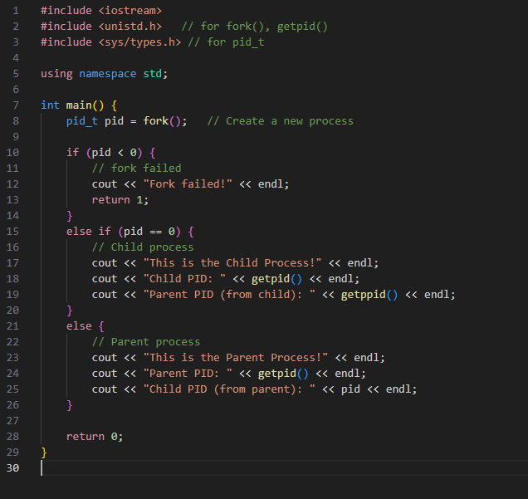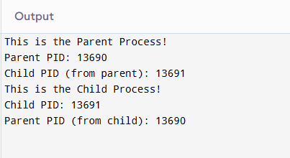

- getpid(): Returns the process Id of the process.
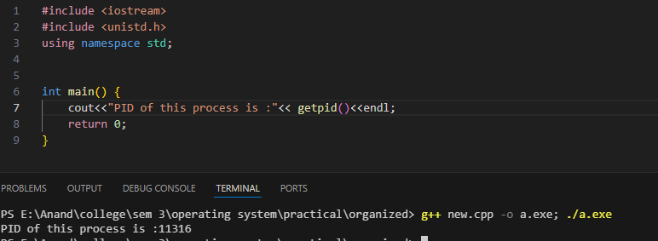

- ps: Its primary function is to report a snapshot of the currently running processes on your system
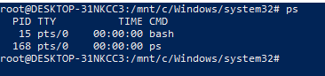

- Kill: It is used to send signals to process (SIGKILL, SIGTERM, SIGHUP)
SIGTERM: Allows program to terminate gracefully
SIGHUP: It re-reads configuration files and restarts without stopping the main process
SIGKILL: Forcefully terminates the process. Can lead to data loss
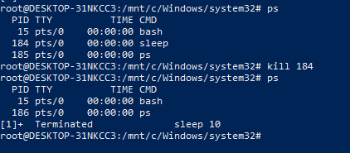

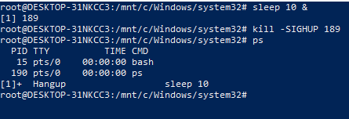
- Sleep: Pauses execution for the specified time
Sleep <time> <unit(s,m, h, d)>
Stops execution for 445 seconds

ii. Communication Control
- Input-Output Redirection: <<, >> Output redirection sends the Standard Output (stdout) of a command to a file instead of the screen.
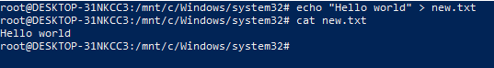
> It sends the screen output into the file. IT overwrites the existing file.

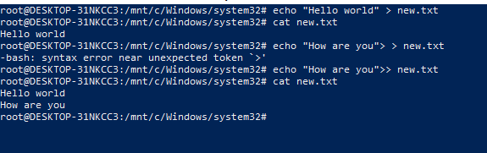
>> appends at the end of the file it exists.

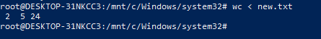
< can be used to give input from a file.

- Pipe: Pipe(|) is used to combine commands. It send the stdout of a command to another command.
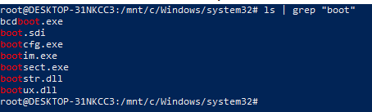
The output of ls is sent to the grep.

iii. Protection Management:
- chmod: Used to change permissions for the file/directory
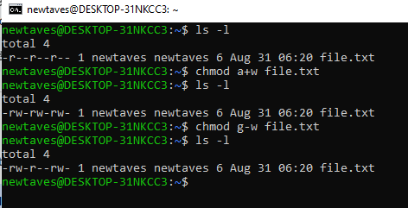

- chown: Used to change ownership of the file/directory
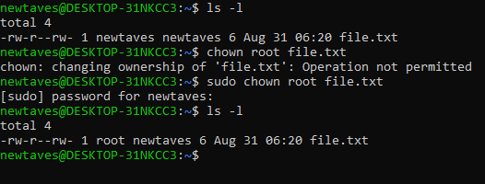

- chgrp: Used to change group of the file/directory
